
SOH TimeAttendance WebForms Software Manual
Table of Contents
- Introduction
  - Overview of the system
  - System requirements
  - Key features
- Getting Started
  - Logging in
  - Password reset
  - First-time setup
  - [Insert Screenshot: Login Page]
- Main Dashboard
  - Dashboard overview
  - Navigation menu
  - Quick widgets
  - Notifications
  - [Insert Screenshot: Dashboard Overview]
- Employee Features
  - Profile management
  - Employee directory
  - Settings (notifications, privacy)
  - [Insert Screenshot: Employee Profile Page]
- Attendance & Clock Events
  - Clock in/out process
  - Viewing clock events
  - Attendance summary
  - [Insert Screenshot: Clock In/Out Interface]
- Timesheet Management
  - Submitting timesheets
  - Viewing history
  - Correcting rejected timesheets
  - [Insert Screenshot: Timesheet Entry Form]
- Leave Management
  - Checking leave balance
  - Requesting leave
  - Cancelling leave
  - Manager approvals
  - [Insert Screenshot: Leave Request Form]
- Payroll & Payments
  - Viewing payslips
  - Payroll calculations
  - Payment methods
  - Pay history
  - [Insert Screenshot: Payslip View]
- Documents & Compliance
  - Uploading documents
  - Managing compliance status
  - Resolving violations
  - Compliance reports
  - [Insert Screenshot: Document Upload Form]
- Administrative Functions
  - Shift management
  - Department management
  - User management
  - System settings
  - Reports & audit trail
  - [Insert Screenshot: Admin Settings Page]
- Troubleshooting
  - Common issues and solutions
  - Contacting support
- FAQs
  - General questions
  - Leave questions
  - Payroll question

Introduction
🌐 What is TimeAttendance.WebForms?
TimeAttendance.WebForms is a modern, web-based time and attendance management system designed to streamline workforce administration. It helps organizations:
- ⏱️ Track Attendance: Monitor employee clock-in and clock-out events in real time
- 📅 Manage Shifts: Create, assign, and adjust employee schedules
- 📝 Process Timesheets: Submit, review, and approve weekly or monthly timesheets
- 🌴 Handle Leave Requests: Request, approve, and track different types of leave
- 💰 Run Payroll: Automate salary calculations, deductions, and allowances
- 📂 Maintain Records: Store employee documents and compliance information
- 📊 Generate Reports: Produce detailed attendance, payroll, and compliance reports
[Insert Screenshot: Application Home Page]

💻 System Requirements
To access and use TimeAttendance.WebForms, ensure the following prerequisites are met:
- 🌍 Web Browser: Latest version of Chrome, Firefox, Safari, or Microsoft Edge
- 📡 Internet Connection: Stable broadband or corporate network access
- 🔑 User Account: Valid credentials with appropriate role-based permissions

⭐ Key Features
- ⏱️ Real-Time Attendance Tracking Monitor employee clock-in and clock-out events instantly, ensuring accurate records of working hours.
- 📅 Flexible Shift Management Create, assign, and adjust employee shifts to match operational requirements.
- 🌴 Leave Management Request, approve, and track different types of leave with clear visibility of balances and history.
- 📝 Timesheet Entry & Management Submit weekly or monthly timesheets, review total hours, and manage approvals for payroll processing.
- 💰 Payroll Processing Automate salary calculations, deductions, and allowances to generate accurate employee payments.
- 📊 Compliance Monitoring Track mandatory documentation and certifications, and receive alerts for pending or expired items.
- 📂 Document Management Upload, store, and manage employee records such as contracts, certifications, and performance reviews.
- 📈 Comprehensive Reports Generate detailed attendance, payroll, leave, and compliance reports in multiple formats (PDF, Excel).
[Insert Screenshot: Feature Overview Page]

🚀 Getting Started
🔐 Logging In
- 🌍 Navigate to the Login Page
  - Open your preferred web browser (Chrome, Firefox, Safari, or Edge).
  - Enter the application URL: http://posking-001-site2.mtempurl.com/
  - The login page will appear.
[Insert Screenshot: Login Page]
- 👤 Enter Your Credentials
  - Username: Type in your company-assigned username.
  - Password: Enter your secure password.
  - Click the “Sign In” button to proceed.
[Insert Screenshot: Credentials Entry Form]
- ✅ Authentication
  - The system will verify your credentials.
  - If successful, you’ll be redirected to the Main Dashboard.
  - If login fails, an error message will appear — double-check your username and password before retrying.
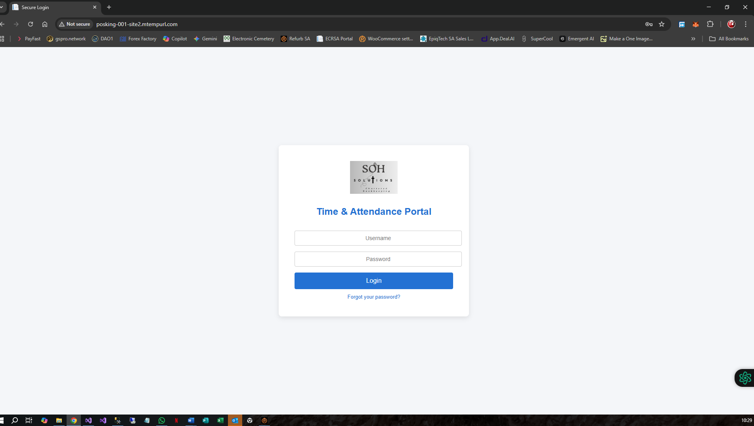

✅ Authentication
- 🔍 Your credentials will be verified against the system.
- 📊 Upon successful login, you will be redirected to the Main Dashboard.
- ⚠️ If login fails, an error message will appear — double-check your username and password before retrying.
[Insert Screenshot: Successful Login Redirect]
🔑 Forgot Password
If you’ve forgotten your password, follow these steps:
- 🖱️ Click the “Forgot Password?” link on the login page.
- 📧 Enter your Email Address in the provided field.
- 📤 Click “Send Reset Link”.
- 📬 Check your email inbox for a password reset link.
- 📝 Follow the instructions in the email to create a new password.
- 🔐 Return to the login page and sign in using your new password.
[Insert Screenshot: Forgot Password Form]
[Insert Screenshot: Password Reset Email Example]

🛠️ First Login Setup
When you log in for the first time, the system may prompt you to complete some initial setup tasks. These ensure your account is personalized and ready for full use:
- 👤 Update Your Employee Profile Information Enter or verify your personal details such as name, contact information, department, and emergency contact. [Insert Screenshot: Employee Profile Setup Page]
- 🔔 Set Up Notification Preferences Choose how you’d like to receive alerts (email, SMS, or in-system notifications) for shift changes, leave approvals, and payroll updates. [Insert Screenshot: Notification Preferences Page]
- 📜 Accept Company Policies Review and acknowledge company policies or compliance requirements before proceeding. [Insert Screenshot: Policy Acceptance Page]
✅ Completing these steps ensures you have full access to all system features and a smooth experience going forward.

📊 Main Dashboard
🖥️ Dashboard Overview
The Dashboard is your central hub for managing daily activities and tracking key information. From here, you can quickly access:
- ⏱️ Attendance Status – A summary of whether you are currently clocked in or out.
- 📅 Upcoming Shifts & Schedules – View your next assigned shifts and planned work schedule.
- 🌴 Pending Leave Requests – Track leave requests awaiting approval.
- 📝 Recent Timesheets – Review your most recent submissions and approval status.
- 🔔 Important Notifications – Stay updated with system alerts and company announcements.
- ⚡ Quick Navigation – Access frequently used features with one click.

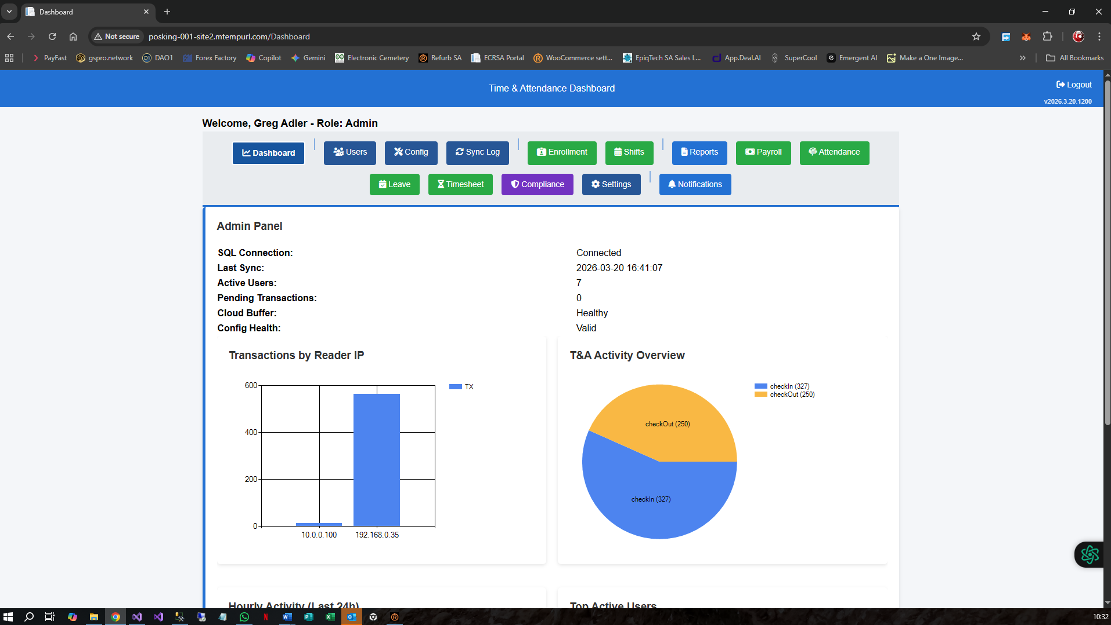

🧩 Dashboard Components
1️⃣ Header Section
The Header Section provides quick access to essential information and actions:
- 🏢 Company Logo – Displays your organization’s branding for easy recognition.
- 👋 Welcome Message – A personalized greeting to confirm you’re logged in.
- 📆 Current Date/Time – Shows the system’s date and time for reference.
- 🔓 Logout Option – Located in the top-right corner, allowing you to securely exit the system.
[Insert Screenshot: Dashboard Header Section]

2️⃣ Navigation Menu
The left sidebar provides quick access to the main sections of the system:
📌 Menu Item | 🛠️ Function
🏠 Dashboard | Home page with summary information
⏱️ Attendance Tracking | View clock events and daily attendance
📋 My Clock Events | Detailed record of all clock-in/out times
📝 Timesheet | View and manage timesheets
🌴 Leave | Request, view, and manage leave
💰 Payroll | View payslips and payment information
👤 Employee Self-Service | Update personal information
📊 Reports | Generate and view reports
⚙️ Settings | Configure user preferences
[Insert Screenshot: Navigation Sidebar Menu]

3️⃣ Quick Widgets
The Quick Widgets section provides at-a-glance information to help you stay on top of your workday:
- ⏱️ Today’s Status – Shows whether you are currently clocked in or out.
- 📊 This Week’s Hours – Displays the total hours you’ve worked so far this week.
- 📨 Pending Approvals – Lists items awaiting your action, such as timesheets or leave requests.
- 🌴 Leave Balance – Shows your remaining leave days by type.
- 📅 Shift Schedule – Highlights your next scheduled shift.
[Insert Screenshot: Quick Widgets Section]
4️⃣ Notifications
The Notifications panel keeps you updated with important system alerts and company messages:
- 🔔 System Updates – Appear as notifications in the dashboard.
- 👆 Click to View Details – Select a notification to see full information.
- 🗑️ Dismiss When Ready – Notifications remain visible until you manually dismiss them.
[Insert Screenshot: Notifications Panel]

🧭 Navigating the Dashboard
- 🖱️ Click on any menu item – Instantly open the section you want to access from the sidebar.
- 🧩 Use Breadcrumbs – Follow the path displayed (e.g., Home > Section > Page) to understand your current location in the system.
- 🏢 Click the Company Logo – Return to the Main Dashboard at any time with a single click.
- 🔍 Use the Search Bar (if available) – Quickly find specific information, employees, or records without browsing through menus.
[Insert Screenshot: Dashboard Navigation Example]

👥 Employee Features
🧾 Employee Profile Management
👀 Viewing Your Profile
To view your employee profile:
- 🖱️ From the Dashboard, click “Employee Self-Service” or navigate to “Settings”.
- 👤 Select “My Profile” from the menu.
- 📋 Your complete profile information will be displayed, including personal details, department, and contact information.

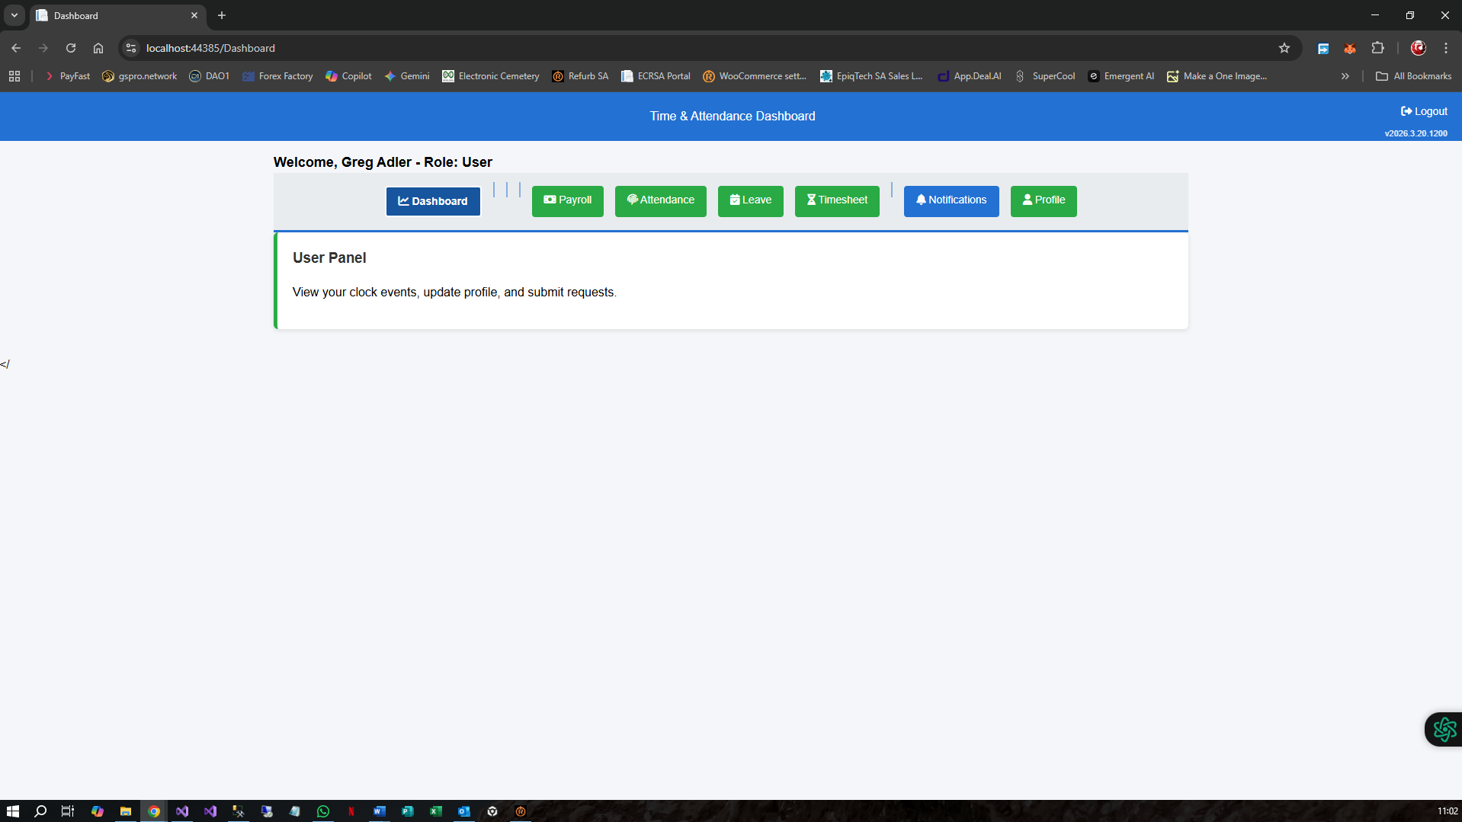
✏️ Updating Your Profile
To update your employee profile information:
- 🖱️ Click the “Profile” button from the Employee Self-Service menu.
- 📝 Update the following fields as needed:
  - 👤 Full Name
  - 📧 Email Address
  - 📞 Phone Number
  - 🏢 Department
  - 💼 Job Title
  - 🏠 Address
  - 🚨 Emergency Contact
- 💾 Click the “Save Changes” button to apply updates.
- ✅ A confirmation message will appear once your changes are successfully saved.
Note: 🔒 Some fields may be locked and can only be modified by administrators.
[Insert Screenshot: Profile Update Form] [Insert Screenshot: Save Confirmation Message]

### Employee Directory

#### Viewing the Employee Directory

1. From the main menu, navigate to **"Employee Self-Service"**
2. Click on **"Directory"** or **"Employee Lookup"**
3. A list of all employees will be displayed
4. Use the **search bar** to find a specific employee:
- Type employee name or ID
- Results will filter in real-time
5. Click on an employee name to view their profile

#### Employee Information Visible
- Full name and employee ID
- Department and position
- Contact information (if accessible)
- Current shift assignment

### Employee Settings

#### Notification Preferences

1. Go to **"Settings"** → **"Notification Settings"**
2. Choose your preferences:
- ☐ Email notifications for shift changes
- ☐ Email notifications for leave approvals
- ☐ Email notifications for payroll updates
- ☐ Email notifications for compliance violations
- ☐ SMS notifications (if available)

3. Click **"Save Preferences"**

#### Privacy Settings

1. Navigate to **"Settings"** → **"Privacy"**
2. Configure what information is visible to other employees
3. Choose your preferences and click **"Save"**

---

## Attendance & Clock Events

### Clock In / Clock Out

#### Manual Clock Entry

1. From **Dashboard**, click **"Attendance Tracking"**
2. Click **"Clock In"** button to record your arrival
- System records current date and time
- Confirmation message appears

3. Later, click **"Clock Out"** to record departure
- Clock out time is recorded
- Total hours for the day are calculated

*Screenshot: Clock in/out interface*

#### Status Indicators

- **🟢 Clocked In**: You are currently working
- **🔴 Clocked Out**: You are not currently working
- **⏳ Pending**: Clock entry awaiting approval

### My Clock Events

#### Viewing Clock Events

1. Click **"My Clock Events"** from the main menu
2. A table displays all your clock events:
- Date
- Clock In Time
- Clock Out Time
- Total Hours
- Status

3. **Filter options** (if available):
- Select date range
- Filter by month/year
- Search by date

*Screenshot: Clock events table*

#### Editing Clock Events

**Note**: Clock events can typically only be edited with manager approval.

1. Find the clock event you want to edit
2. Click the **"Edit"** button (if available)
3. Modify the time if necessary
4. Click **"Submit for Approval"**
5. Your manager will review and approve/reject the change

#### Correcting Clock Entries

If you forgot to clock in/out:

1. Go to **"My Clock Events"**
2. Find the relevant date
3. Click **"Request Correction"**
4. Enter the correct time
5. Add a note explaining why correction is needed
6. Click **"Submit"**
7. Your manager will review the request

### Attendance Summary

#### Monthly Attendance Overview

1. Go to **"Attendance Tracking"**
2. Click **"Monthly Summary"** tab
3. View:
- Total hours worked
- Number of days present/absent
- Number of late arrivals
- Leave taken
- Overtime hours

4. Download as PDF or Excel (if available)

---

## Timesheet Management

### Understanding Timesheets

A **Timesheet** is a formal record of your working hours, organized by week or month. It's different from clock events because:
- It's typically submitted weekly or monthly for approval
- It may include notes and project assignments
- It requires manager approval
- It's used for payroll processing

### Submitting Your Timesheet

#### Step 1: Open Timesheet Entry

1. From the main menu, click **"Timesheet"** → **"Timesheet Entry"**
2. Select the timesheet period (week/month)
3. The timesheet form will open

*Screenshot: Timesheet entry form*

#### Step 2: Fill in Hours

1. For each day in the period:
- Click the day's row
- Enter hours worked (or system may auto-populate from clock events)
- Enter project/task information (if required)
- Add any notes or comments

2. **Daily hours breakdown** (if applicable):
- Morning hours
- Afternoon hours
- Overtime hours

#### Step 3: Review Total Hours

1. Check that the **Total Hours** matches your work
2. Verify all entries are accurate
3. Review any overtime hours calculated

#### Step 4: Submit Timesheet

1. Click **"Submit Timesheet"** button
2. A confirmation dialog appears
3. Click **"Confirm Submission"**
4. Status changes to "Pending Approval"
5. You'll receive a confirmation notification

*Screenshot: Timesheet submission confirmation*

### Viewing Timesheet History

1. Go to **"Timesheet"** → **"Timesheet History"**
2. A list of all submitted timesheets appears
3. Click on any timesheet to view details:
- Dates covered
- Total hours
- Approval status
- Approver's comments (if any)

4. **Filter by**:
- Date range
- Status (Approved, Pending, Rejected)
- Month/Year

### Timesheet Status

- **Draft**: You're still editing
- **Pending Approval**: Submitted, waiting for manager review
- **Approved**: Manager approved, used for payroll
- **Rejected**: Manager rejected, you can edit and resubmit

### Correcting a Rejected Timesheet

1. Find the rejected timesheet in history
2. Click **"Edit"**
3. Make necessary corrections
4. Review manager's comments (in Notes section)
5. Click **"Resubmit"**
6. Manager will review again

---

## Leave Management

### Types of Leave

Your organization may offer:
- **Annual Leave**: Vacation days
- **Sick Leave**: For illness
- **Personal Leave**: Personal reasons
- **Compassionate Leave**: Family emergencies
- **Other**: Special leave types

### Checking Leave Balance

#### Quick View

1. From the **Dashboard**, look at the **"Leave Balance"** widget
2. Your remaining leave days are displayed by type

#### Detailed View

1. Click **"Leave"** → **"Leave Balance"**
2. A detailed breakdown shows:
- Leave type
- Total entitlement
- Used to date
- Remaining balance
- Expiry date (if applicable)

*Screenshot: Leave balance page*

### Requesting Leave

#### Step 1: Initiate Leave Request

1. From the main menu, click **"Leave"** → **"Request Leave"**
2. Click **"New Leave Request"** button

*Screenshot: Leave request form*

#### Step 2: Fill in Leave Details

1. **Select Leave Type**:
- Choose from dropdown (Annual, Sick, Personal, etc.)

2. **Select Start Date**:
- Click date picker
- Choose first day of leave
- Or type date in format MM/DD/YYYY

3. **Select End Date**:
- Choose last day of leave
- System calculates number of days

4. **Days Duration**:
- Full days or partial days
- If partial: select which part (morning/afternoon)

5. **Reason** (optional):
- Type the reason for leave
- e.g., "Family vacation" or "Doctor's appointment"

6. **Remarks** (optional):
- Additional information for approver
- Contact information while away

#### Step 3: Review Request

1. Review all information carefully
2. Check dates and duration are correct
3. Verify you have sufficient balance
4. Confirm reason is appropriate

#### Step 4: Submit Request

1. Click **"Submit Leave Request"**
2. Confirmation message appears
3. Status changes to "Pending Approval"
4. You'll receive email confirmation

*Screenshot: Leave request submission confirmation*

### Viewing Leave Requests

#### Leave Request History

1. Go to **"Leave"** → **"Leave History"**
2. All your leave requests appear in a table:
- Start and end dates
- Leave type
- Number of days
- Current status

3. **Filter by**:
- Date range
- Status (Pending, Approved, Rejected, Cancelled)
- Leave type

#### Leave Request Details

1. Click on any request to view full details
2. See:
- Approval history (who approved, when)
- Approver's comments
- Any attachments or notes

### Leave Request Status

- **Pending**: Awaiting manager approval
- **Approved**: Manager approved
- **Rejected**: Manager rejected with reason
- **Cancelled**: You cancelled the request
- **On Leave**: Currently on approved leave

### Cancelling Leave

1. Find the leave request in history
2. If status is "Pending" or "Approved" and not yet started:
- Click **"Cancel Leave"** button
- Confirm cancellation
- Request is cancelled and days returned to balance

3. If leave has already started, contact HR

### Leave Approval (For Managers)

#### As a Manager, Approving Leave

1. Go to **"Leave"** → **"Leave Approval"**
2. View pending leave requests from your team
3. For each request:
- Review dates and reason
- Click **"Approve"** or **"Reject"**
- Add comments if necessary
- Click **"Submit"**

4. Employee receives notification immediately

---

## Timesheet Approval (For Managers)

### Approving Submitted Timesheets

1. From menu, go to **"Timesheet"** → **"Timesheet Approval"**
2. List shows all pending timesheets from your team
3. For each timesheet:
- Click to view details
- Review hours and any notes
- Click **"Approve"** or **"Reject"**
- Add comments if rejecting
- Click **"Submit"**

4. Employee receives notification

---

## Payroll & Payments

### Understanding Payroll

**Payroll** refers to:
- Salary and wage calculations
- Deductions and allowances
- Net pay (what you take home)
- Tax withholdings

### Viewing Payslips

#### Accessing Payslips

1. From the main menu, click **"Payroll"** → **"Payslips"**
2. A list of your payslips appears, organized by date

*Screenshot: Payslips list*

#### Payslip Details

1. Click on any payslip to view details
2. The payslip shows:

| Section | Details |
|---------|---------|
| **Payment Period** | Date range covered |
| **Basic Salary** | Your base pay |
| **Allowances** | Additional payments (overtime, bonuses, etc.) |
| **Gross Pay** | Total before deductions |
| **Deductions** | Tax, insurance, etc. |
| **Net Pay** | Your take-home amount |

3. **Actions available**:
- Download as PDF
- Print
- Email to personal account

*Screenshot: Detailed payslip view*

### Payroll Calculation

#### Understanding Your Pay Calculation

1. Go to **"Payroll"** → **"Payroll Calculation"**
2. View how your pay is calculated:
- Hours worked × hourly rate
- Plus allowances (if applicable)
- Minus deductions
- Equals net pay

3. If you have questions about calculations, contact HR or Payroll department

### Payment Methods

#### Checking Payment Details

1. Go to **"Payroll"** → **"Payment Settings"** (if available)
2. View:
- Bank account on file
- Payment frequency (weekly/monthly/bi-weekly)
- Payment method (direct deposit, check, etc.)

3. **To update payment details**:
- Contact HR department (for security reasons, typically not self-service)

### Employee Pay History

1. Go to **"Payroll"** → **"Pay History"**
2. View all historical payslips
3. Filter by:
- Date range
- Year
- Payment status

4. Download multiple payslips at once (if available)

---

## Documents & Compliance

### Uploading Employee Documents

#### Supported Document Types

- Employment letters
- Certifications
- Training records
- Medical documents
- Tax documents (W-4, I-9, etc.)
- Performance reviews
- Contracts

#### Uploading a Document

1. Go to **"Documents"** → **"Employee Documents"**
2. Click **"Upload New Document"** button

*Screenshot: Document upload form*

3. Fill in document details:
- **Document Type**: Select from dropdown
- **Title**: Name/title of document
- **Description**: Brief description
- **Upload Date**: Automatically populated
- **Expiry Date**: If applicable (certifications, etc.)

4. **Select file**:
- Click "Choose File"
- Navigate to document on your computer
- Click "Open"

5. **File requirements**:
- Maximum size: 10 MB
- Accepted formats: PDF, DOC, DOCX, XLS, XLSX, JPG, PNG
- Scan quality should be clear and legible

6. Click **"Upload Document"**
7. Confirmation message appears

#### Managing Uploaded Documents

1. Go to **"Documents"** → **"My Documents"**
2. All your uploaded documents appear in a list
3. For each document:
- **View**: Click document name to open
- **Download**: Click download icon
- **Delete**: Click delete icon (if not required)
- **Replace**: Re-upload if updated

### Compliance Status

#### Understanding Compliance

**Compliance** means meeting company and legal requirements, such as:
- Completed tax forms
- Medical clearances
- Training certifications
- Document verifications

#### Checking Your Compliance Status

1. Go to **"Compliance"** → **"Compliance Status"**
2. View your compliance dashboard

*Screenshot: Compliance status page*

3. Sections show:
- ✅ **Completed**: Requirements met
- ⚠️ **Pending**: Awaiting documents or action
- ❌ **Violations**: Non-compliance issues

4. For each item:
- See the requirement
- See deadline (if applicable)
- See required action

#### Resolving Compliance Violations

1. Go to **"Compliance"** → **"Compliance Violations"**
2. View any compliance issues

*Screenshot: Compliance violations list*

3. For each violation:
- Click to view details
- See reason and deadline
- See required action
- Upload missing document or mark as resolved

4. Example violations:
- Missing tax documentation
- Expired certifications
- Incomplete employee profile
- Missing emergency contact

#### Taking Action on Violations

1. Click on the violation
2. View required action
3. **If document is needed**:
- Go to Documents section
- Upload the required document
- Violation status updates automatically

4. **If information is needed**:
- Go to Employee Profile
- Update the missing information
- Save changes

5. Once resolved, the violation clears from your list

### Document Compliance Reports

1. Go to **"Reports"** → **"Compliance Reports"**
2. View comprehensive compliance information:
- Employee compliance status
- Missing documents by type
- Upcoming expirations
- Violations summary

3. Download report as PDF

---

## Administrative Functions

*Note: These sections are typically only available to managers and administrators.*

### Shift Management

#### Managing Shifts

**Managers and Admin can:**

1. Go to **"Shift Management"**
2. View all shifts:
- Shift name and code
- Assigned employees
- Shift times
- Status (Active/Inactive)

3. **Create New Shift**:
- Click "Add Shift"
- Enter shift name and code
- Set start and end times
- Assign employees
- Click "Save"

4. **Edit Shift**:
- Click on shift name
- Modify details
- Click "Update"

5. **Assign Shift to Employee**:
- Click "Assign Shift"
- Select employee
- Select shift
- Set effective date
- Click "Assign"

6. **Bulk Operations**:
- Select multiple shifts
- Perform actions on all selected
- Examples: Deactivate, Export, Archive

### Department Management

#### Managing Departments

**Admin/Managers can:**

1. Go to **"Department Management"** (or **"Config Tools"**)
2. View all departments:
- Name and code
- Description
- Number of employees
- Status

3. **Add Department**:
- Click "Add Department"
- Enter department name
- Enter department code
- Add description
- Click "Save"

4. **Edit Department**:
- Click on department
- Update information
- Click "Update"

5. **Configure Department Settings**:
- Leave entitlements
- Shift patterns
- Overtime eligibility
- Pay types

### User Management

#### Managing User Accounts

**Administrators can:**

1. Go to **"Admin"** → **"User Management"**
2. View all users:
- Name and email
- Role/Permission level
- Status (Active/Inactive)
- Last login date

3. **Add New User**:
- Click "Add User"
- Enter name and email
- Assign role (Employee, Manager, Admin)
- Click "Create"
- System sends activation email to user

4. **Edit User**:
- Click on username
- Update role or permissions
- Click "Save"

5. **Deactivate User**:
- Click "Deactivate"
- User can no longer log in
- Can be reactivated later

6. **Reset User Password**:
- Click on user
- Click "Reset Password"
- System sends reset email to user

### System Settings & Configuration

#### Accessing Configuration

1. Go to **"Admin"** → **"System Settings"** or **"Config Tools"**
2. Available configuration options:
- Date and time format
- Timezone settings
- Currency settings
- Language preferences
- Company information
- Integration settings (if applicable)

3. Modify settings as needed
4. Click "Save Settings"
5. Changes take effect immediately

### Generating Reports

#### Report Types Available

1. **Attendance Reports**:
- Daily attendance
- Monthly attendance summary
- Attendance by department
- Late arrival reports

2. **Payroll Reports**:
- Payroll summary
- Employee earnings
- Deductions report
- Tax report

3. **Leave Reports**:
- Leave taken by employee
- Leave balance
- Leave approval log
- Leave forecast

4. **Compliance Reports**:
- Compliance status
- Violations by department
- Document completion status
- Audit trail

#### Running a Report

1. Go to **"Reports"**
2. Select report type
3. Choose parameters:
- Date range
- Department (if applicable)
- Employee (if applicable)
- Report format (Table, Chart, Summary)

4. Click **"Generate Report"**
5. Report appears on screen
6. Options to:
- **View**: Display report
- **Download**: Save as PDF or Excel
- **Print**: Print directly
- **Email**: Send report via email

*Screenshot: Report generation interface*

#### Scheduling Reports

1. Go to **"Reports"** → **"Scheduled Reports"**
2. Click "Schedule Report"
3. Choose:
- Report type
- Frequency (Daily, Weekly, Monthly)
- Recipients (email addresses)
- Delivery time
4. Click "Schedule"
5. Report runs automatically and delivers to recipients

### Audit Trail

#### Viewing System Activity

**Administrators can:**

1. Go to **"Admin"** → **"Audit Trail"**
2. View log of system activities:
- Who performed the action
- What action (clock in, timesheet submitted, etc.)
- When it occurred
- Changes made
- Remarks/notes

3. **Filter by**:
- User
- Date range
- Action type
- Department

4. **Search**:
- Find specific entries
- Keyword search available

5. **Export**:
- Download audit log
- Useful for compliance and investigation

### Sync and Data Management

#### Syncing Clock Events

**Admin can sync data from time clocks:**

1. Go to **"Admin"** → **"Sync Log"** or **"System Tools"**
2. Click **"Sync Clock Data"**
3. System imports clock events from readers
4. Progress bar shows sync status
5. Results show:
- Records processed
- Errors encountered
- Time taken
- Summary of new entries

4. View **Sync History**:
- All previous sync operations
- Date and time of sync
- Number of records synced
- Any errors

5. Download **Data Access Log** if needed

---

## Troubleshooting

### Common Issues and Solutions

#### Issue 1: Cannot Log In

**Problem**: "Invalid username or password"

**Solutions**:
1. Check that CAPS LOCK is off
2. Verify spelling of username (case-sensitive)
3. Try resetting password using "Forgot Password" link
4. Clear browser cache and cookies:
- Chrome: Ctrl+Shift+Delete → Clear browsing data
- Firefox: Ctrl+Shift+Delete
- Edge: Ctrl+Shift+Delete
5. Try a different browser or device
6. Contact IT Support if problem persists

#### Issue 2: Clock In/Out Not Recording

**Problem**: Clock in/out button doesn't work

**Solutions**:
1. Check your internet connection
2. Refresh the page (Ctrl+R or Cmd+R)
3. Try a different browser
4. Click the button again (page may be processing)
5. Check if you're already clocked in
6. Verify the correct date and time on your device
7. Contact administrator if problem continues

#### Issue 3: Timesheet Won't Submit

**Problem**: "Submit Timesheet" button is disabled

**Solutions**:
1. Verify all required fields are filled in
2. Check that hours are entered for all days
3. Ensure total hours is correct
4. Fix any validation errors shown in red
5. Try saving first, then submitting
6. Refresh page and try again

#### Issue 4: Leave Balance Shows Incorrect

**Problem**: Leave balance doesn't match expectations

**Solutions**:
1. Go to **"Leave History"** to verify approved leave
2. Check for pending leave requests (not counted until approved)
3. Verify calculation is correct: Total - Used = Remaining
4. Check for leave that expires at year-end
5. Contact HR if balance seems wrong

#### Issue 5: Page is Loading Slowly

**Problem**: Pages take a long time to load

**Solutions**:
1. Check your internet connection speed
2. Close other browser tabs to free up memory
3. Clear browser cache
4. Try a different browser
5. Try on a different device
6. Contact IT if pages are consistently slow

#### Issue 6: Document Upload Fails

**Problem**: "File upload failed" error

**Solutions**:
1. Check file size (must be under 10 MB)
2. Verify file format (PDF, DOC, XLS, JPG, PNG only)
3. Try a different file
4. Try uploading from a different device
5. Use a modern browser (Chrome, Firefox, Edge)
6. Contact IT for technical assistance

#### Issue 7: Report Won't Generate

**Problem**: Report generation fails or hangs

**Solutions**:
1. Try with a smaller date range
2. Refresh the page
3. Try a different report
4. Close other browser tabs
5. Check your internet connection
6. Try at a less busy time of day
7. Contact administrator

### Contacting Support

#### Getting Help

**For Technical Issues:**
- Email: `it-support@company.com`
- Phone: `+1-555-0100`
- Ticket: Submit through system help form

**For HR/Payroll Issues:**
- Email: `hr@company.com`
- Contact HR department directly

**For Shift/Attendance Issues:**
- Contact your manager first
- Escalate to HR if not resolved

#### Information to Provide

When requesting support, include:
1. Your name and employee ID
2. Description of the problem
3. Steps you've already tried
4. Error message(s) shown
5. Browser and device information
6. Date and time the issue occurred
7. Screenshots if possible

---

## FAQs

### General Questions

**Q: When should I clock in?**
A: Clock in when you arrive at work and are ready to begin your shift. Clock in time should match your scheduled shift start time.

**Q: When should I clock out?**
A: Clock out when you finish work for the day. Clock out time marks the end of your working hours.

**Q: What if I forget to clock in/out?**
A: Go to "My Clock Events" and click "Request Correction" for the day you missed. Enter the correct time and add a note. Your manager will review and approve.

**Q: Can I edit my clock times?**
A: You can request a correction for legitimate reasons (system error, forgot to clock). Your manager must approve any changes.

**Q: How often should I submit my timesheet?**
A: Typically weekly or monthly, depending on your company policy. Check with your manager or HR.

### Leave Questions

**Q: How much leave am I entitled to?**
A: View your "Leave Balance" in the system. Entitlements vary by company and employment type. Check with HR for details.

**Q: Can I take leave in half days?**
A: Yes, most companies allow partial day leave. Select "Partial Day" when requesting and choose morning or afternoon.

**Q: How long does leave approval take?**
A: Usually 1-2 business days. You'll receive notification when your request is approved or rejected.

**Q: What if my leave request is rejected?**
A: The rejection includes a reason. Contact your manager to discuss alternatives or resubmit for different dates.

**Q: Can I take leave back-to-back with weekends?**
A: Yes, your leave extends your time off. Include weekends in your request if desired.

**Q: What happens to unused leave?**
A: This depends on company policy. Some companies allow carryover, others have a "use it or lose it" policy. Check with HR.

### Payroll Questions

**Q: When will I get paid?**
A: Check your payslip to see the payment date. Typically on the same date each month.

**Q: Why is my pay different this month?**
A: Check your payslip for changes:
- Different number of hours worked
- Additional allowances
- Deductions (tax changes, insurance, etc.)
- Overtime pay
- Bonuses

**Q: Can I change my direct deposit information?**
A: Contact HR/Payroll department. For security reasons, this is typically not available for self-service.

**Q: What deductions are on my payslip?**
A: Common deductions include:
- Income tax
- Social security/pension
- Health insurance
- Other benefits

Contact HR if you have questions about specific deductions.

**Q: Can I get a copy of my payslip?**
A: Yes, download from "Payroll" → "Payslips". You can also request printed copies from HR.

### Shift Questions

**Q: How do I know my shift schedule?**
A: View your shifts in "Dashboard" or "My Shifts". Your manager assigns shifts.

**Q: Can I request a shift change?**
A: Contact your manager to request a shift change. They must approve and update your schedule.

**Q: What if I can't work my assigned shift?**
A: Contact your manager as soon as possible. Don't simply not show up.

**Q: Can I swap shifts with a coworker?**
A: Some companies allow this. Check with your manager for the procedure.

### Technical Questions

**Q: What browser should I use?**
A: Any modern browser works:
- Google Chrome (recommended)
- Mozilla Firefox
- Apple Safari
- Microsoft Edge

For best experience, keep your browser updated.

**Q: Can I access the system on my phone?**
A: Yes, the system is mobile-responsive. Some features may be limited on small screens.

**Q: Is the system secure?**
A: Yes, the system uses:
- HTTPS encryption
- Secure login
- Session timeout for security
- Regular security updates

**Q: What is the browser cache?**
A: Cache stores website files locally. Clearing it:
- Can fix loading issues
- Removes old data
- May slow first load after clearing
- Usually safe to clear

**Q: Why was I logged out?**
A: Common reasons:
- You were inactive for too long (usually 30 minutes)
- Server was restarted
- You logged in from another location
- Your session expired for security

Simply log back in.

### Department & Organization Questions

**Q: Can I change my department?**
A: Contact HR. Department changes typically require approval.

**Q: Who is my manager?**
A: View in your employee profile or check the employee directory.

**Q: How do I contact my manager?**
A: Use contact information in the employee directory or look at your employee profile.

**Q: What should I do if my manager is unavailable?**
A: Contact the manager's supervisor or HR department for urgent matters.

### Account & Security Questions

**Q: How do I change my password?**
A: Go to "Settings" → "Change Password". Enter your current password, then new password twice.

**Q: What makes a strong password?**
A: A strong password:
- Has at least 8 characters
- Includes uppercase letters (A-Z)
- Includes lowercase letters (a-z)
- Includes numbers (0-9)
- Includes special characters (!@#$%^&*)
- Is NOT your username or easily guessed
- Is NOT reused from previous passwords

**Q: What if I think someone accessed my account?**
A: Immediately change your password and contact IT Support. They can check for unauthorized access.

**Q: Can I use the system from a public computer?**
A: Not recommended. If you must:
- Always use "Logout" when finished
- Don't save passwords
- Use a privacy/incognito browser window
- Clear browser data after use

**Q: How secure is my personal information?**
A: Your data is protected by:
- Encryption in transit and at rest
- Regular security audits
- Access controls (only authorized staff see your data)
- Backup systems
- Compliance with data protection laws

Contact HR for questions about data privacy and retention.

### Compliance & Document Questions

**Q: What documents do I need to upload?**
A: Required documents depend on your role and employment. Common ones include:
- Tax forms (W-4, I-9)
- Government IDs
- Certifications
- Training records
- Background check results

Check your "Compliance Status" for required documents.

**Q: When are compliance violations resolved?**
A: Once you upload required documents or information, violations automatically clear from the system.

**Q: What happens if I don't complete compliance requirements?**
A: Depends on company policy. May result in:
- Inability to receive pay
- Suspension of benefits
- Disciplinary action
- Termination (for serious violations)

**Q: Can I download my documents?**
A: Yes, go to "Documents" and click the download icon next to any document.

---

## Appendix

### A. System Features by Role

#### Employee (All Staff)

✓ View personal profile
✓ Clock in/out
✓ View attendance records
✓ Submit timesheets
✓ Request leave
✓ View payslips
✓ Upload documents
✓ View compliance status
✓ Access employee directory
✓ Change personal settings

#### Manager

All Employee features, plus:

✓ View team timesheets
✓ Approve/reject timesheets
✓ Approve/reject leave requests
✓ View team attendance
✓ Assign shifts
✓ View team reports
✓ Review compliance status of team
✓ Manage department (some)

#### Administrator

All Manager features, plus:

✓ User account management
✓ System configuration
✓ Department management
✓ Create and manage shifts
✓ Data synchronization
✓ System reports and analytics
✓ Audit trail access
✓ Backup and data management
✓ Integration management

### B. Keyboard Shortcuts

| Action | Shortcut |
|--------|----------|
| Clear browser cache | Ctrl+Shift+Delete (Cmd+Shift+Delete on Mac) |
| Refresh page | Ctrl+R (Cmd+R on Mac) |
| Zoom in | Ctrl+Plus (Cmd+Plus on Mac) |
| Zoom out | Ctrl+Minus (Cmd+Minus on Mac) |
| Full screen | F11 |
| Open dev tools | F12 |
| Close current tab | Ctrl+W (Cmd+W on Mac) |

### C. Glossary of Terms

| Term | Definition |
|------|-----------|
| **Allowance** | Additional payment beyond base salary (e.g., shift allowance) |
| **Audit Trail** | Log of all system activities and changes |
| **Clock Event** | A recorded clock in or clock out |
| **Compliance** | Meeting all required standards, policies, and legal requirements |
| **Deduction** | Amount subtracted from gross pay (taxes, insurance, etc.) |
| **Direct Deposit** | Automatic payment to your bank account |
| **Gross Pay** | Total earnings before deductions |
| **Leave Balance** | Remaining leave days available |
| **Leave Entitlement** | Total leave days you're entitled to |
| **Net Pay** | Take-home pay after all deductions |
| **Overtime** | Hours worked beyond standard shift |
| **Payslip** | Document showing pay calculation and deductions |
| **Shift** | Assigned working hours for a day |
| **Timesheet** | Formal record of hours worked, typically weekly/monthly |
| **Violation** | Non-compliance with a requirement |

### D. Contact Information

#### Support Departments

| Department | Contact | Hours |
|-----------|---------|-------|
| **IT Support** | it-support@company.com / +1-555-0100 | 8 AM - 6 PM weekdays |
| **HR Department** | hr@company.com / HR Office Ext. 101 | 8 AM - 5 PM weekdays |
| **Payroll** | payroll@company.com / Ext. 150 | 8 AM - 4 PM weekdays |
| **Facilities** | facilities@company.com / Ext. 200 | 8 AM - 6 PM weekdays |

### E. System Maintenance Schedule

The system undergoes maintenance during the following windows:

- **Weekly**: Every Saturday 2 AM - 4 AM (server backups)
- **Monthly**: 2nd Saturday of month, 1 AM - 3 AM (updates and patches)
- **Quarterly**: To be announced (major updates)

During maintenance, the system is unavailable. Backup systems allow limited functionality.

### F. Version Information

**Current System Version**: As displayed in dashboard footer
**Last Updated**: [Date]
**Next Major Release**: [Date]

---

## Document Information

- **Title**: TimeAttendance.WebForms - End User Guide
- **Version**: 1.0
- **Last Updated**: [Current Date]
- **Target Audience**: All system users (Employees, Managers, Administrators)
- **Language**: English
- **Format**: PDF-ready Markdown

---

## Quick Reference Card

### Quick Navigation

```
Dashboard → Home and overview
Attendance Tracking → Clock in/out and attendance
My Clock Events → Detailed clock records
Timesheet → Submit and manage hours
Leave → Request and view leave
Payroll → View pay and payslips
Documents → Upload and manage documents
Compliance → Check compliance status
Reports → Generate system reports
Employee Self-Service → Update personal information
Settings → User preferences
Admin/Config (if applicable) → System administration
```

### Common Tasks (Quickstart)

**Clock In**:
1. Click Dashboard → Attendance Tracking → Clock In

**Submit Timesheet**:
1. Click Timesheet → Timesheet Entry
2. Fill in hours
3. Click Submit

**Request Leave**:
1. Click Leave → Request Leave
2. Select dates and type
3. Click Submit

**View Payslip**:
1. Click Payroll → Payslips
2. Click desired payslip
3. Download or print

**Upload Document**:
1. Click Documents → Employee Documents
2. Click Upload New
3. Select file
4. Click Upload

**Check Compliance**:
1. Click Compliance → Compliance Status
2. Review items
3. Upload missing documents if needed

---

## Document Notes

**PDF Generation Instructions**:

This markdown document can be converted to PDF using:
1. **Online**: Use markdown-to-PDF converters
2. **Tool**: Pandoc, wkhtmltopdf, or similar
3. **Browser**: Print to PDF from Chrome or Firefox
4. **Word**: Copy to Word and export as PDF

**Recommended PDF Settings**:
- Paper size: A4
- Margins: 1 inch (2.54 cm)
- Font size: 11pt minimum
- Preserve links and formatting
- Include table of contents

**Distribution**:
- Provide PDF to all users upon onboarding
- Include in employee handbook
- Make available on intranet
- Update annually or as system changes

---

**End of User Guide**

For the most current information and support, contact IT Support or visit the company intranet.

Last printed: [Date]

